

Blood Bank Management System

Group 8



PROG8750 – Capstone (Web Development)

24S - SECtion 7

Submitted to: Joyce Domingo

**Team Members:**

Shukla, Rachna

Maninderpal Singh

Harmander Singh

Thotekat Albey, Abraham Charles

Sanklecha, Nidhi Rajesh

**Blood Bank Management System**

**Introduction**

The Blood Bank Management System (BBMS) is an online platform designed to efficiently manage and analyze information related to the administration and inventory of blood banks. This system aims to keep track of blood donors and the different blood types available, and enhance the management of these resources. The primary goal is to ensure transparency, eliminate corruption in the blood donation process, and improve the overall effectiveness of blood bank operations.

Donors interested in giving blood must register in the database, and their information will be stored securely. The software integrates seamlessly with customer relationship management (CRM) and content management system (CMS) solutions. Blood requests can be made through the system, and donor information will be provided. Donors can also update their availability status.

With the implementation of this project, finding and managing blood supplies is expected to become faster, easier, and more reliable. Administrators can access donor information and view blood availability based on user requests.

**Benefits of Blood Bank Management System (BBMS)**: **Revolutionizing Blood Bank Operations**

Blood bank management is crucial for Canada's healthcare system, ensuring the availability of safe and compatible blood for transfusions. Traditional blood bank management often relies on manual processes and paper records, leading to various issues. Limited data accessibility makes it hard for staff to track inventory, donor details, and blood compatibility efficiently. Manual tracking is time-consuming and error-prone, increasing the risk of discrepancies in blood supply.

BBMS offers a centralized database for real-time monitoring and automated tracking of blood products, streamlining operations and eliminating manual tasks. It offers a comprehensive solution enhancing the overall efficiency of blood bank operations.

**Key Benefits of BBMS:**

* **Enhanced Blood Inventory Management**:
  + Real-time monitoring ensures adequate stock levels to meet patient demands.
  + Automated processes streamline blood donation and inventory management.
* **Improved Blood Matching**
  + Advanced algorithms to reduce the times for identifying compatible blood products.
  + Automation minimises human error, enhancing patient safety.
* **Ensuring Blood Safety**
  + enhanced tracking from donation to transfusion ensures compliance with regulatory standards, protecting patients from risks and boosting the facility’s credibility.
* **Cost-Effectiveness**:
  + reduces manual labour and streamlines processes minimising operational costs.
  + Optimises inventory levels and minimises wastage, contributing to cost savings.
* **Integration with Healthcare Systems:**
  + Seamless integration with existing healthcare systems facilitates efficient communication and coordination, ensuring timely transfusions.
* **Scalability and Flexibility:**
  + BBMS can adapt to changing needs, whether expanding services or adjusting operations, ensuring continued efficiency.
* **Enhanced Donor Management:**
  + Automates donor registration, screening, and communication, improving the donor experience and retention rates.
  + Maintains comprehensive donor records, strengthening relationships with donors.
* **Data Analytics and Insights:**
  + Elaborating data analytics for decision making command BBMS can forecast blood demand and optimize inventory levels.
  + Predictive analytics help identify risks and opportunities for proactive management.
* **User Friendly Interface**:
  + Intuitive design makes it easy for staff to learn and use, reducing training time and increasing productivity.
  + Ongoing support and training health staff maximise BBMS benefits.

**Design and Data Flow:**

**Entities and Attributes:** For a Donor, attributes like DonorID, Name, Gender, Age, Contact, BloodGroup and AvailabilityStatus etc. For Patient, attributes like PatientID, Name, BloodGroup and DateOfIntake etc. For Blood, BloodID and BloodGroup etc. For RegistrationTeam, TeamID and Name.

**Relationships:** A Donor donates Blood. A Patient receives Blood. A Donor registers with the RegistrationTeam. Blood has both DonorID and PatientID as foreign keys to link donations and transfusions.

**Data Flow**: The Blood Bank Management System (BBMS) begins with the registration of donors. Donors provide their essential information, including DonorID, Name, Gender, Age, Contact details, and BloodGroup, to the Registration Team. The team then registers the donors in the system, ensuring that their availability status is updated and accurately reflected within the database.

When a donor decides to donate blood, a new entry is created in the system to record this donation. This entry includes the DonorID, BloodGroup, and the Date of Donation. Following the donation, the system updates the donor's availability status to reflect their recent contribution, ensuring the database remains current and accurate.

In scenarios where a patient requires a blood transfusion, a blood request is submitted specifying the necessary BloodGroup. The system then searches its database for available blood units that match the requested BloodGroup. Once a suitable match is found, the relevant blood entry is updated to include the PatientID and the Date of Intake, ensuring a seamless allocation of blood to the patient in need.

Additionally, donors have the ability to update their availability status within the system. This feature allows donors to indicate whether they are currently available to donate blood, ensuring that the database accurately represents the donor's current status and availability for future donations. This dynamic update capability helps maintain an efficient and responsive blood management system.

**Design:**

User registration screen

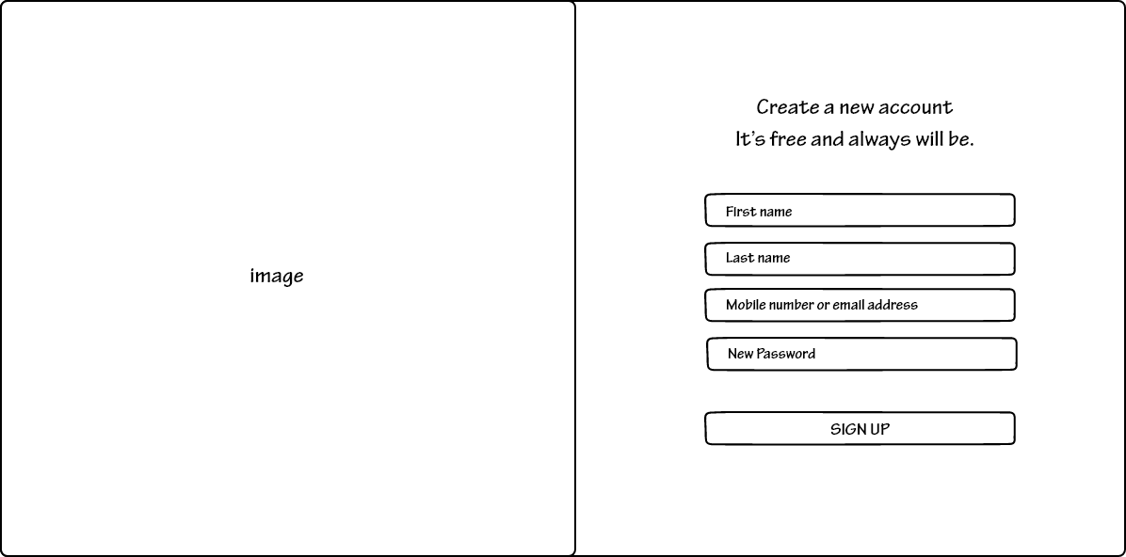

Home screen

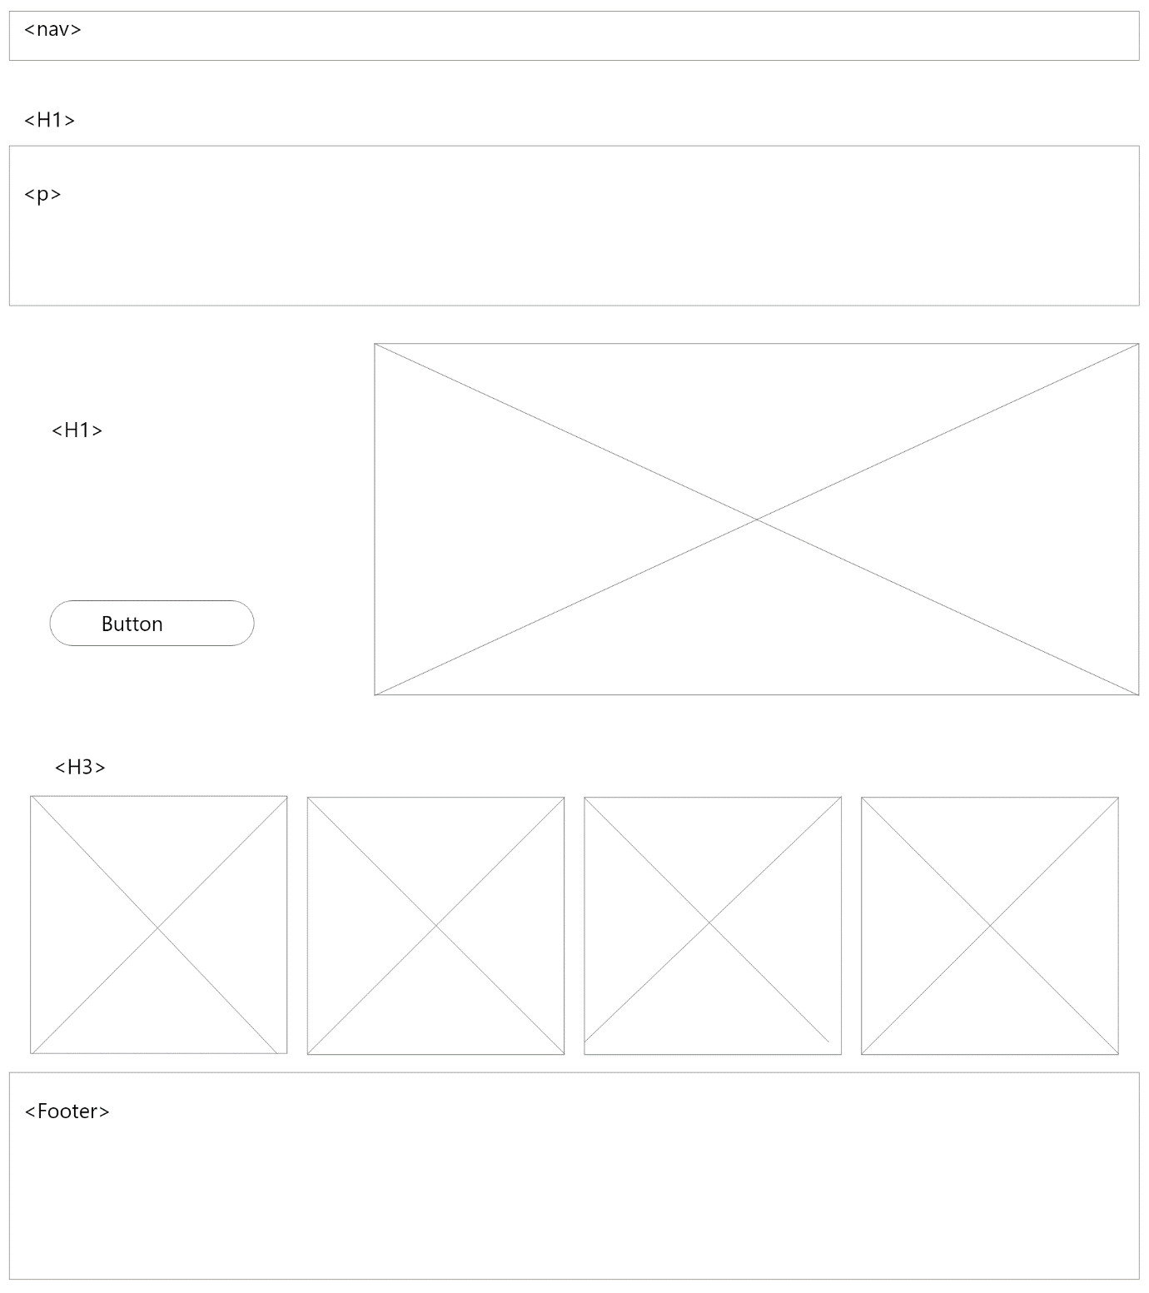

Home screen mobile view

About us screen

About us screen mobile view

Blood bank screen

Blood bank screen mobile view

**Technology Description:**

To build an effective and efficient Blood Bank Management System (BBMS), we have chosen to utilize MongoDB, React, Node.js, and Express. These technologies offer robust solutions tailored to both the frontend and backend requirements of the system, ensuring a seamless and responsive experience for users. Here’s a detailed explanation of why each of these technologies is used:

**MongoDB** is selected for its scalability and flexibility. As a NoSQL database, MongoDB is designed to handle large volumes of data and can scale effortlessly, which is crucial for a BBMS that needs to store extensive donor and blood inventory data. Its document-oriented structure allows for a flexible schema design, making it easier to manage the varying data types and relationships inherent in blood bank operations. It provides high read and write speeds, which are essential for real-time data processing and retrieval. Its built-in replication and high availability features ensure that the system remains operational and that data is consistently accessible, even in the event of hardware failures.

**React** is chosen for developing the user interface due to its component-based architecture, which facilitates the creation of reusable UI components. This is particularly useful for designing complex interfaces for donor registration, blood inventory management, and patient requests. React’s use of a virtual DOM enhances performance by minimizing direct updates to the real DOM, resulting in a faster and more responsive user experience.

**Node.js** is utilized for the backend due to its ability to allow full-stack development using a single language—JavaScript. This streamlines the development process and reduces the complexity of switching between different programming languages. Node.js’s asynchronous and event-driven nature makes it highly efficient for handling I/O operations, which is crucial for real-time data processing and communication in a BBMS.

**Express** is employed as the web application framework for its minimalist and flexible nature. It provides robust features for building a streamlined backend for the BBMS, including middleware support that enables easy implementation of authentication, logging, and error handling—critical for the secure and reliable operation of the system. Express’s straightforward and efficient routing mechanism allows the creation of RESTful APIs that can effectively handle requests for donor registration, blood donations, and blood requests. Its seamless integration with various databases, including MongoDB, and other tools facilitates the creation of a cohesive and efficient backend infrastructure.

By leveraging MongoDB, React, Node.js, and Express, we can create a robust, scalable, and efficient Blood Bank Management System. These technologies provide the necessary tools to handle large volumes of data, ensure high performance and availability, and deliver a responsive and intuitive user interface, ultimately enhancing the overall efficiency and reliability of blood bank operations.

**Market Survey:**

Based on recent job postings and market trends, here are the top ten technologies currently in high demand:

1. Artificial Intelligence (AI) and Machine Learning (ML)
2. Python
3. Cloud Computing
4. Cybersecurity
5. Data Analytics and Visualization
6. Java
7. MERN
8. Linux
9. JavaScript
10. Networking

These technologies reflect current market needs and can guide your project selection to enhance your job prospects after graduation.

**Conclusion:**

To ensure timely and structured development, the project will be divided into four sprints, each focused on a specific aspect of the system: Blood, Patient, Registration Team, and Donor. Each sprint will have a duration of approximately two weeks, with defined milestones and deliverables to track progress and ensure the project stays on schedule. This project is supposed to be concluded by mid August.

**GitHub link:**

<https://github.com/NidhiSanklecha1325/Blood_Bank_Management_System.git>

**JIRA link:**

<https://bloodbank.atlassian.net/jira/software/projects/SCRUM/boards/1?atlOrigin=eyJpIjoiOTE4NGYxYzE4NTYxNDU1M2FkMmI0YWQ2Y2U4Yjc1YzkiLCJwIjoiaiJ9>